Pendientes
- Post redirect checker estan todas con 404
- El robot txt crear un redirect
- Asociar el GA ID con el Google search console

Post Go-Live
Preparas el mail:
- Sitio: es el que está live, en este caso el final.
- Hago el mismo análisis que en pre go-live check
Luego chequeo:
Domains hosted:
- Go to Commerce / Hosting / Domains and check that all the necessary domains are hosted in NetSuite.
  - If migrating a subdomain, check that it is hosted
  - If migrating a root domain, www and root domain should be hosted
  - If migrating a www, root domain and www should be hosted
  - If migrating another domain, the old and the new domains should be hosted.
- Only the primary domain should be hosted as “Single Domain for Web Store and Checkout”.
- No domain should be hosted as “Redirect URL”
- Make sure that all domains are hosted correctly:
  - If secure, it should be hosted as “Secure Web Store” (excluding primary domain as we see before)
  - If non-secure, it should be hosted as “Web Store Only”
- In case you found a missing domain or an error, include it on the Post Go-Live email conclusion.

Hago los pasos de Google search console.
Luego, Nos falta una parte, le estamos errando en el robots.txt, que esto es lo que está en la guía:
**********************************************************************************
robots.txt:

- We must confirm if robots.txt is configured to allow crawlers to access to the site. Robots.txt should be configured as:
User-agent: *
Allow: /

How to check robots.txt?
- Go to the site URL and add “/robots.txt” at the end
- If it says “Allow: ”, “Disallow: /” or “Disallow: ” it is because it is not configured. If it appears as indicated above, it is correctly configured.
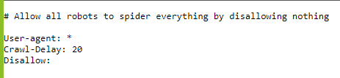
Tiene que estar como allow, no tiene que prohibir nada.

How to configure robots.txt?
- Go to customer NetSuite backend
- Documents / Files / File cabinet
- Click on Web Site Hosting Files.
- Click on Live Hosting Files
- Click on Add file (top left) and select the robots.txt file located on the local folder of the project. Import it. (para password protected es siempre disallow /)
  - If customer has more that one site in the same NetSuite account, the robots.tx file for our project should be named “nameofthesite_robots.txt”. Then, we should create a redirect from “/robots.txt” to “nameofthesite_robots.txt”.
    - Go to Commerce / Hosting / Redirects and click on New.
What do we fill up here?
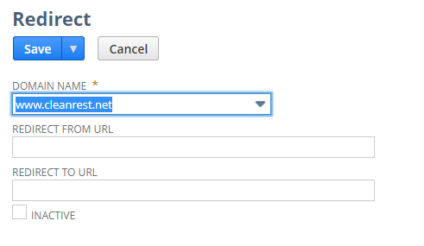
**********************************************************************************
Terminando las indicaciones de la guía:
En nuestro sitio, tenemos un único redirect:
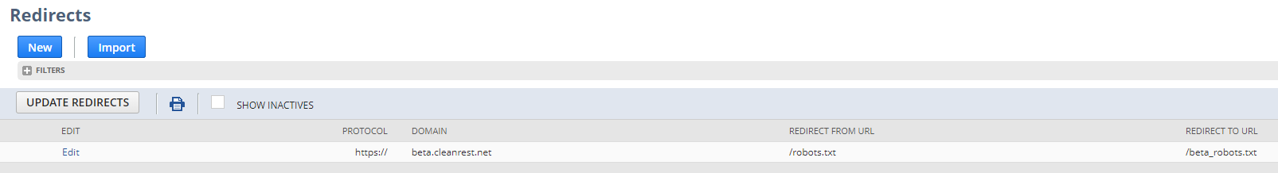
Este redirect es para beta.cleanrest.net, tenemos que agregar el redirect nuevo para nuestro dominio www.cleanrest.net.
Esto no se como hacerlo porque me pide url from y redirect to url

Siguiendo la guía: NO TENGO ACCESO A GOOGLE ANALYTICS
En la parte de Google search console y Google analytics configuration
Link the Google Search Console property to the Google Analytics property.
- Go to Settings (left menu) and click on Associations.
- Click on Associate and paste the Google Analytics Property ID to associate. Select the correct one and click on Continue
- Confirm the association

Esta parte no la puedo avanzar, porque no aparece en el associate la ID de Google analytics:
